Welcome to

Meon Valley
Lions Club (CIO)
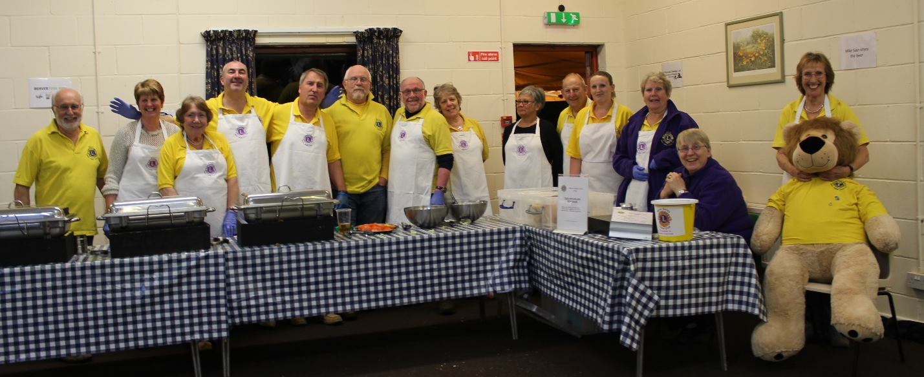

New members’ handbook

A little bit about Meon Valley Lions Club
Meon Valley Lions is a local club that is part of a network of Lions Clubs International with over 1.44 million volunteer members around the world.

The Club was founded on 24 January 1973, sponsored by Fareham Lions Club, our “mother” club and so we are now approaching 50 years old. Our current membership is 25 and we also have over 20 “Friends of Lions” who help with some of our various activities.

There is no defined geographical area in Lions but our patch roughly covers a wide area from Curdridge to West Meon to Denmead to Wickham and Knowle Village.

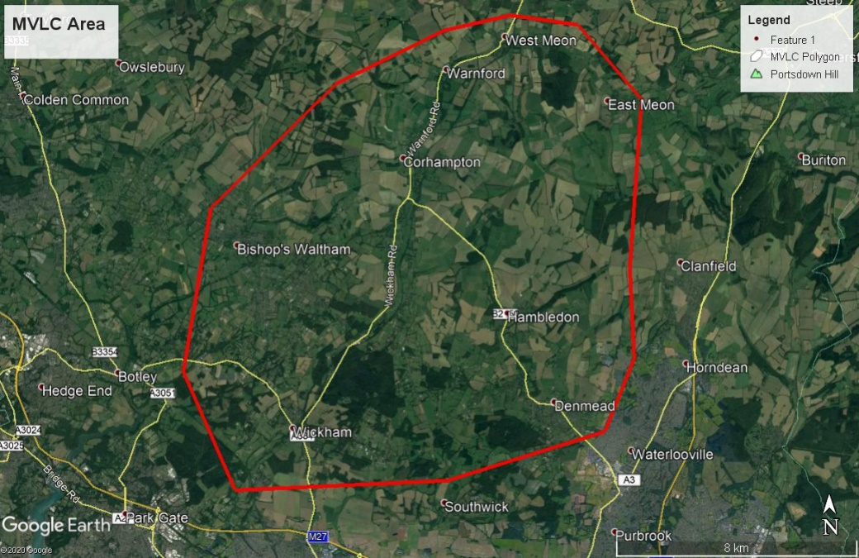

Our aim is to support people and communities in our area and to have an active social calendar so that we can have fun at the same time There is a caveat to our individual contributions and that is that “You give what time you have but never at the expense of your family and business”.

Meetings
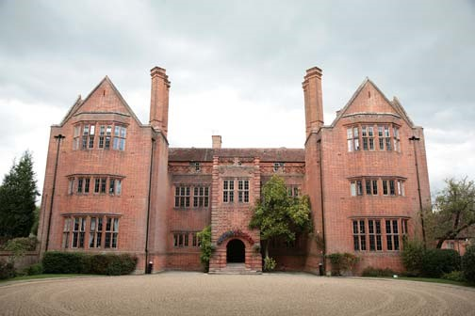
A meeting of the members is held on the first Monday of each month (except bank holidays when it is put back to the second Monday). This is called a business meeting and is held at 7.30pm at the New Place Conference Centre Shirrell Heath

The President (in his / her year of office commencing 1st July) runs the meeting to an agenda produced by and supported by the Secretary.

To keep the meetings manageable and as succinct as possible there are sub-committees, comprising Welfare, Fundraising, Social and Membership who meet monthly/as necessary to progress matters and produce reports for Business meetings.

Club members will join at least one of the committees and, each year, are encouraged to move from one committee to another to broaden their experience.

Sometimes, we have visitors from other clubs and Lions Districts and we also invite people to attend who seek support for a project or who have been partly funded by Lions so that they can tell the Club how they got on.

At the main business meeting
- The President chairs, supported by the Club Secretary
and Club Treasurer, who sit together
- Members sit wherever they want and dress is casual
- The meeting starts at 7.30pm and the aim is to finish by 9 pm.
- Hot drinks and water are available
- The agenda, committee and other reports are forwarded before the meeting and a member is expected to advise the Secretary (email or phone) if he/she is not able to attend
- Any decisions needed are voted on by a show of hands. Visitors do not have a vote. The meeting aims to reach agreement at the meeting but may defer if further information/consideration is required
- Meetings have to have some structure and formality but that doesn’t stop a bit of fun in the process and, at the end of the meeting, a nominated member (the Tail Twister) imposes a fine for a small misdemeanour, the amount being decided by the offending member, such as not wearing the Lion’s badge, misconstruing or making fun of another member’s comment, etc.

Some of the terms you may hear at meetings

Lions hierarchy
- LCI: (Lions Clubs International) the global Lions organisation
- District: The United Kingdom is divided into districts and we are in district 105 SC.
- Zone: Each District is then sub divided into smaller Zones and Meon Valley Lions Club is in Zone C. The Clubs in Zone C with us are Alton, Havant, Hayling Island, Petersfield and Woolmer Forest.

Badging Up: This is where someone is made a member and given their badge, which should be worn, where possible, when involved in Lion’s work but always at meetings.

Charter: Celebration of the anniversary of the club, towards the end of March, that is usually a lunch or dinner.
Club Handover: This is where the serving President hands over to the incoming President. Though there are some light-hearted speeches, this is an informal social occasion.

District Governor: He/she heads up the district for one year.

LCIF: Lions Clubs International Foundation provides funding for large scale humanitarian projects around the world.

Lion Tamer: This member looks after the Club’s banners and flags, regalia and equipment

Zone Chairman: This person heads up the Zone for a year.

Welfare

Our principal Aims

The main focus in Welfare is towards providing support, financially and otherwise, to identified individuals and local charitable organisations e.g. foodbanks. The Club’s activities encourage our involvement in the wider community so that we can mix with that community and identify needs. With our Minibus we provide transport for the elderly (eg. Lunch clubs). We are also committed to providing support to Youth through grants to local organisations and individuals. Each year we donate 10% of fundraising monies to the Lions Club International Foundation Disaster Fund to help those around the world affected by disasters.

Minibus
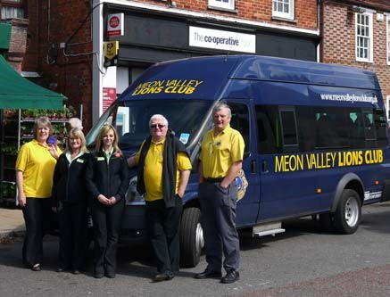
We own a 17-seater minibus which is driven by members, Friends of Lions and drivers from other charitable bodies we support.
Typically, the minibus is used 4 times during the week for transport and, then with our trailer, for transporting members and Lion’s equipment to fundraising and other activities at the weekend. Occasional and selective loans mean that passenger trips in the year can be over 3,000.

Other Charities
Though we mainly operate locally, we will also work with national charities if they support residents of the Meon Valley. In recent years, we have been able to support Rose Road Association, MacMillan Nurses, Action for The Children, Home Start (who support mainly single parent families), Naomi House (children’s palliative care), Mountbatten Hampshire hospice, Age Concern, Canine Partners, amongst others, in their own fundraising events/activities, with BBQ services, car parking etc.

These are some of the projects the committees get involved in. The events are organised by the committees but the whole club is normally asked to help at the event.

Paulton’s Park
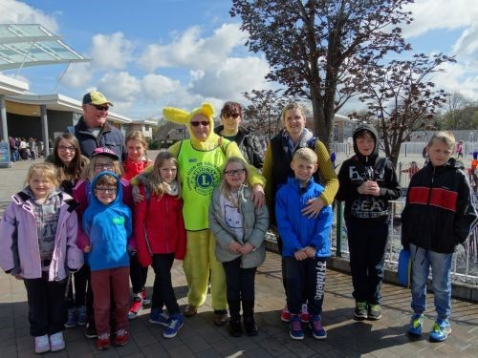
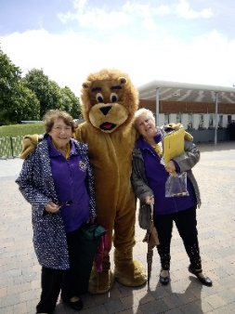 Initiated by our Lion’s District, we take up to 100 children to the park for the day, providing them with a fun day which they might not otherwise have and at a discounted price agreed with Paulton’s Park.

Spek-Trek
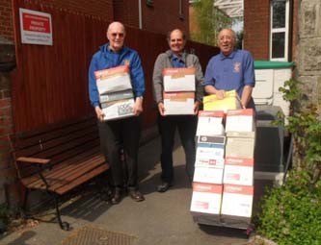
Internationally organised, no-longer needed prescription glasses are collected through the year and sent overseas to be recycled and given to those who cannot afford them. Over 500 pairs are collected by our Club during the year and a recent initiative is developing for hearing aids.

Message in a Bottle
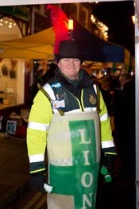
Small bottles are distributed through surgeries and chemists for people, living on their own. Personal and medical details are kept in the bottle and are available to emergency services in the event of an incident.

Fundraising

Through our various activities the club raises money. All the money we raise goes to help those in need and the causes we support. No charity money is used for the administration of the Lions Club organisation. Donations by card and text or through our donate link will be subject to a small charge made by the companies providing these services and costs associated with our other fund-raising events are deducted.

We have also benefited in the past from donations from local authorities, businesses and individuals who recognise the value of what Lions bring to the local community. In a typical year, we raise in the order of £18,000 and spend around 90% of this locally with the balance going to the LCIF Disaster Fund.

Christmas Float
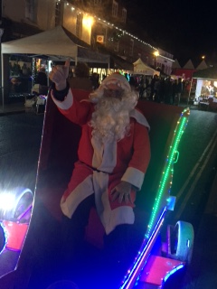
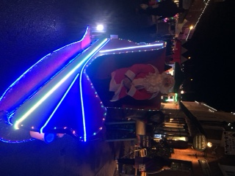
Through much of December, up to Christmas Eve, our minibus, complete with sleigh and carols, goes out in the evening to many parts of our area, complete with Santa, lollies for the children, and his helpers to collect donations as we knock on doors. We also undertake static collections at the weekends.

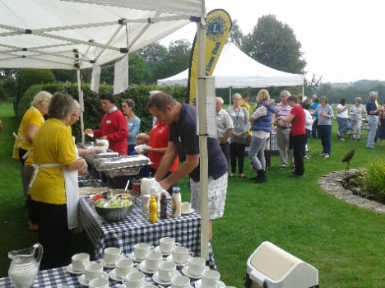
BBQ Services
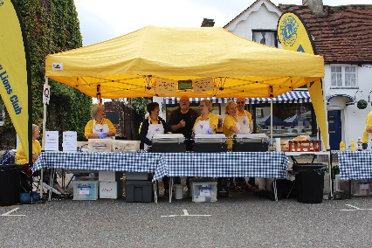
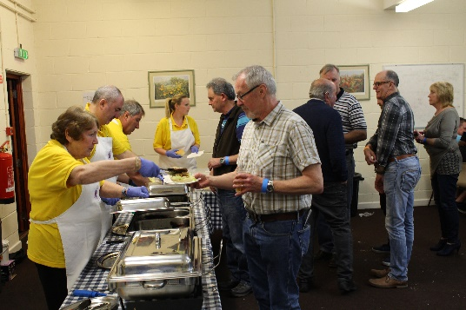
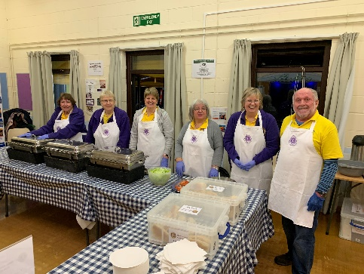
We have built up an impressive range of BBQ equipment which is used for Lions’ events and supporting others, complete with members who “staff” the service. Wickham Beer Festival and Taste of Wickham are our major events. We’re also five-star rated by the FSA (Food Standards Agency)! A substantial amount of money has been raised in this way and enables us to make “virtual income” donations of the net profit to a charity when appropriate.

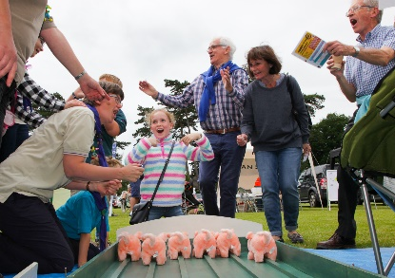
Fetes
As well as running the Swanmore Lion’s Fete, we attend several fetes/fairs/shows where we provide BBQ Services, and various stalls including “Play Your Cards Right”, Coconut Shies, Racing Pigs, etc.

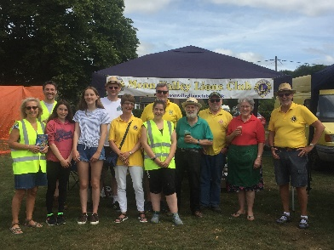

Fishing Festival
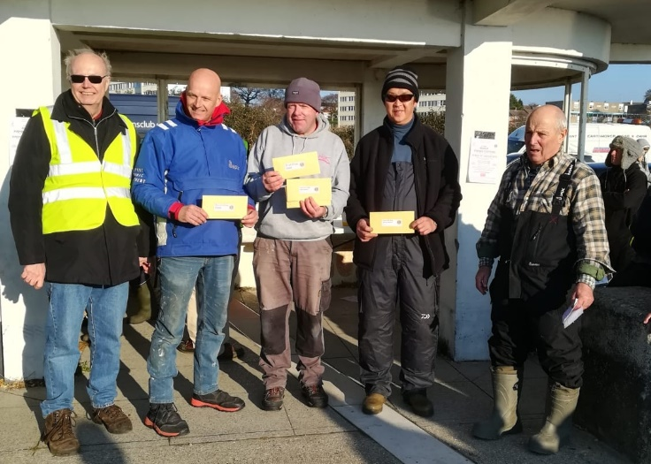
Held in January each year and organised by Ford Sea-Angling Club we support with the signing in of typically 100 anglers on Weston Shore in Southampton, selling raffle tickets and overseeing the weigh-in.
.

Social
The Club considers this an essential part of our activity and enjoyment and encourages members and their partners to attend as many events as possible. “The glue that keeps the Club together”.

The following are a few of the events which are “regulars” in our calendar: -

Pub Night, a get together for a drink & a chat, is held on the 3rd Monday of the month (other than bank holidays) - 7.30pm, usually at the Rising Sun, Swanmore.

Christmas Dinner at varied locations.

Charter Lunch/Dinner usually at the end of March to mark the anniversary of the forming of the Club.

Changeover to welcome in the new President for a year and to hand over the “chain of office”, hosted by a Lion or Lions. This is held in June/July.

Zone “Get Togethers” to meet with members of the other clubs in our zone.

Day Outings to places of interest e.g. Gardens, breweries, Canal Boats, Trains or just walking usually coupled with lunch.

Parties hosted by a member but with contributions from others.

Members Responsibilities 2022/23

CLUB OFFICE | OFFICERS
President | John Hanley
Vice President
Secretary | Eddy Barringer
Treasurer | Andrew Brown
Deputy Treasurer | Roger Morfill
COMMITTEES | LEAD
Welfare | Sue Barringer
Fundraising | Gary Martin
Publicity | Carole Dash
Web site admin | Sheila Campbell
Catering | Roy Cuthbertson
Fishing Festival | Andrew Brown
Swanmore Fete | Carole Dash
Social | Hilary White
Membership | Roy Cuthbertson
Liontamer / Quartermaster | Dick Cowles
Transport | Brian Edwards
Youth | Dinah Weberstadt
Almoner | Pete Meadows
Health & Safety | Sheila Campbell
Tail Twister | Allison Gurry

Sponsor / Mentor - each new club member has a sponsor / mentor within the club who is there to discuss and support those club activities the member wishes to be involved in and, otherwise, be a source of information and advice.

Club Almoner – normally a member of senior service within the club, who has a responsibility of general awareness towards the needs, welfare and well-being of club members. He/she would react with the offer of assistance and advice in times of illness or crisis.

Thank you!

We hope this booklet helps you understand how Meon Valley Lions is structured and what we are involved in.

Most of us come to the Club through friendship and with an interest in welfare and fundraising in our community and any member will be happy to give their version and what it means to them.

Please ask any questions that you might have.
We will do our best to answer them.

Meon Valley Lions Club (CIO) www.meonvalleylionsclub.org.uk

Updated September 2022

